Turning Images into Sounds using Fourier

Project Design Document

Elana Voigt, Orlala Wentink

11/13/14

Contents

1. Introduction 3

a. Purpose 3

b. Scope 3

c. Definitions and Acronyms 3

2. System Overview 3

3. System Architecture 3

a. Architectural Design 3

b. Design Rationale 3

4. Human Interface Design 3

a. Overview of User Interface 3

b. Screen Images 3

# Introduction

## Purpose

The purpose is to learn how images can be converted into sounds using Fourier analysis and then to implement that idea using LabView.

## Scope

This software aims to use the pixel data of an image to convert that image into sound through Fourier Transforms.

## Definitions and Acronyms

LV: LabView 2014 32-bit

# System Overview

For any signal, the Fourier Transform of the signal tells you the strength of each individual frequency needed to make up that signal. An image is another type of signal and a 2-D Fourier Transform can be taken of the image. This is used in image processing to blur and compress images. Here we will be focusing on taking a 2-D Fourier Transform of an image and then reversing the transform to turn the single into an audio signal.

<http://homepages.inf.ed.ac.uk/rbf/HIPR2/fourier.htm>

<http://www.askamathematician.com/2012/09/q-what-is-a-fourier-transform-what-is-it-used-for/>

<http://stackoverflow.com/questions/13549186/how-to-plot-a-2d-fft-in-matlab>

# System Architecture

## Architectural Design

I’m not sure what to say. We will probably use the MathScript tool.

## Design Rationale

Again, I’m not sure what to say. I assume we will use the MathScript tool because MatLab has a function that takes a 2-D Fourier Transform of an image.

# Human Interface Design

## Overview of User Interface

The use will pick an image. The program will display the strength of the frequencies determined by the 2-D Fourier Transform and will play back an audio version of the signal, in some manner.

## Screen Images

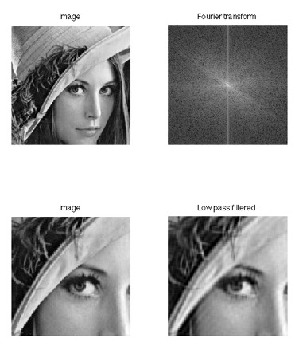

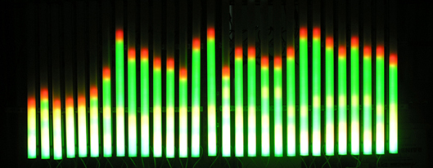

Images from: <http://www.askamathematician.com/2012/09/q-what-is-a-fourier-transform-what-is-it-used-for/>